Abstract

This is the final report document with environment, tasks , user stories, and acceptance criterion.

Readthatbook

Final Report

**Team**:

Prateek Mahendrakar

Raka Choudhury

Ashwini Kadam

Sanju Kurubara Budi Hall Hiriyanna Gowda

**Contents**

Project Proposal 2

Overview and Motivation 2

Scope and Objectives 2

Project Environment and Architecture 3

Environments chosen: 3

Project Architecture 4

Project Requirements 5

Sprint 1 5

Sprint 2 31

Sprint 3 53

Testing: 73

Test 1: 73

Test 2: 73

Test 3: 74

# **Project Proposal**

## **Overview and Motivation**

READTHATBOOK will provide a web based interface for users to search for book of his choice based on user rating and reviews. Users can also rate and review the books and put the books into their wish list. This helps in short listing books for bibliophiles, casual readers and also critics to review books.

As a student, we find a lot of reference books for our coursework and similar books with different authors. Our goal is to help someone to choose the most relevant; good book based on others feedback.

This site can also act as One-stop place for books’ information that a user desires to know before reading or buying a book.

One unique feature as compared existing book sites, the rating will be coupled with reviews so that enthusiasts can know rating in short and glance on review rather going through a page long review.

## **Scope and Objectives**

This application will help users to search for book of their choice, see ratings and reviews.

This will be implemented as a Java web application with a database to store all book and review related information. A simple average calculation for displaying rating is used .Top reviews are selected on the basis of combination of rating and the total number of likes of particular review.

* User to be able to login to a system to keep track of his book reading activity
* General details of books displayed: Description, ISBN, Author, Genre, and Edition.
* Average rating is shown
* Top reviews are shown.
* Rating can range from 1-10.
* Users can add books into their wish list.
* Reviews are bundled with ratings.
* There will be list of books as suggestions to read with similar genre and author.
* An advanced search of books can be performed based on AND combination of ISBN, author, title, genre etc.

The intended users of this application will be professors, authors, book critics, students, corporate employees or any person who might want to read books.

# **Project Environment and Architecture**

All of us are comfortable with Java and hence we chose JSP web application as our platform.

Otherwise learning other languages like PHP, .NET would take more time. Hence all team members decided to go with Java/JSP .

Among IDEs, we considered Eclipse and Netbeans. Both the IDEs provided good features. As per online reviews, Netbeans appeared to be a very consistent product.We noticed that netbeans provided a very good project management window. We were easily able to find and install relevant plugins and it is also easier to map with web server and database. Netbeans also has mapping with git version control. Hence, we chose Netbeans as our development IDE.

We read about multiple JavaScript libraries and searched in blogs about which one would be comfortable to use. None of us have any prior experience with any JavaScript library. Hence we have decide to go with simple javascript.

For Version control ,Netbeans provides GIT plugins which are very convenient.

For Gui testing, we are following manual testing approach.

We are using JUnit for unit test framework.

## **Environments chosen:**

**Languages:** Java web application(HTML+JSP/CSS)

**IDE** - Netbeans 8.1 (Chose 32/64 accordingly)

**Webserver** - Tomcat 8.0.37

**Database** - mySQL

**Client side javaScript library -** JavaScript

**Version control -** git 2.10

**Unit testing framework -** Junit for Java

**Project management tool -** Taiga

**Automated GUI testing -** Sikuli

**Mock up tool -** Lumzy

**Recommended-** Git OpenShift account

# **Project Architecture**

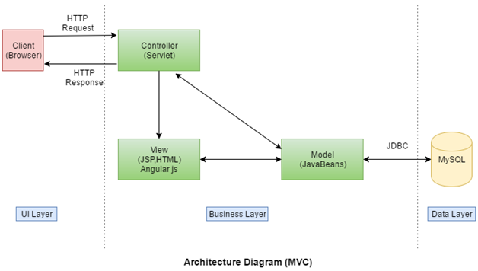

## 

# Project Requirements

## **Sprint 1**

**User stories, tasks and acceptance criterion:**

**User Story:**

As a user, I want to update my account details.

**Acceptance Criteria:**

Given: User ‘XYZ’ is on his account home page.

When: User clicks on My Account à Update profile

Then: ‘Edit profile’ page is displayed

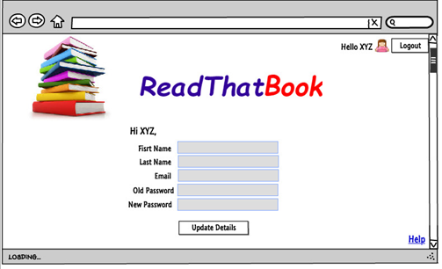

**Acceptance Criteria:**

Given:

User ‘XYZ’ is on Edit profile page

Current email id is : xyz@gmail.com

Firstname : XYZ

Lastname : FGH

When:

User updates values of email id as abc@gmail.com, Firstname as DFG , Lastname as KIL

User clicks on ‘Update Details”

Then:

User email id is updated.

User should be notified with popup saying "Changes to your profile have been saved"

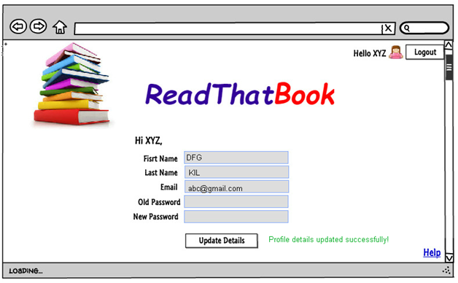

Given: User is logged in to the system with below details

Current email id : xyz@gmail.com

Firstname : XYZ

Lastname : FGH

User is in Update Profile page

When: User updates values of email id as abc.gmail.com, Firstname as DFG , Lastname as KIL

User clicks on ‘Update profile’

Then: User should be notified with popup saying "Email id is invalid"

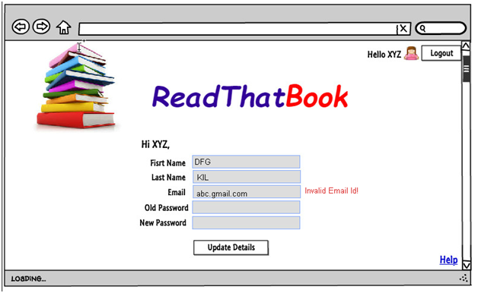

**Tasks:**

|  |
| --- |
| Code and test for update button on myAccount pageSS |
| Create and code editAccount page |
| Code and test for update profile method of UserProfileManager class |
| Code and test UPDATE SQL on USER table |
| Code and test acceptance criteria for update account action |
| Code and test acceptance criteria for view account action. |

**User Story :**

|  |
| --- |
| **As an admin, I want to add a book and its details.**  Acceptance Criteria:  Given:  User is already logged in as Admin.  He is on the “Manage Books” webpage.  Book with ISBN 1234567 does not exist in database.  User clicks on “Add new book” option.    When:  Admin enters all the details (book title, author, ISBN, publisher, edition, genre, description) of book with ISBN 1234567 that is to be added.  Admin clicks on “Add” button.  Then:  “Book added successfully.”- Message is displayed. List of books will now have book with ISBN 1234567.        **Acceptance Criteria:**  Given:  User is already logged in as Admin.  He is on the “Manage Books” webpage.  Book with ISBN 1234567 exists in database.  User clicks on “Add new book” option.  When:  Admin enters all the details (book title, author, ISBN, publisher, edition, genre, description) of book with ISBN 1234567 that is to be added.  Admin clicks on “Add” button.  Then:  “Book with same ISBN already exists.”- Message is displayed.    **Acceptance Criteria:**  Given:  User is already logged in as Admin.  He is on the “Manage Books” webpage.  Book with ISBN 1234567 does not exist in database.  User clicks on “Add new book” option.  When:  Admin enters the details of book with ISBN 1234567 that is to be added.  He enters details - author, ISBN, publisher, edition, genre, description but does not enter book title.  Admin clicks on “Add” button.    Then:  “Please fill all the mandatory fields.” - Message is displayed.    Manage books page displays list of books in which book with ISBN 1234567 is not present.  **Acceptance Criteria:**  Given:  User is already logged in as Admin.  He is on the “Manage Books” webpage.  Book with ISBN 1234567 does not exist in database.  User clicks on “Add new book” option.  When:  Admin enters the details of ‘abc’ book that is to be added.  He enters details – book title, author, publisher, edition, genre, description but does not enter ISBN.  Admin clicks on “Add” button.  Then:  “Please fill all the mandatory fields.” - Message is displayed.    Manage books page displays list of books in which no new book is added. |

**Tasks:**

|  |
| --- |
| Code and Test database queries to add new book and book details. |
| Create Book and Book details related tables in database. |
| Code and test UI for addBookDetails webpage. |
| Code and test BookManager servlet for add book action |
| Code and test "Book" class. |
| Code and test for acceptance criteria of adding book details. |
| Code and test addBook method in BookUtility class |
| Code and test add book button on manageBooks page |

**User Story :**

|  |
| --- |
| **As a guest user , I want to register my account.** |

**Acceptance criteria:**

Given:

User is on home page of the application

When:

User clicks on Register button

Then:

Application displays User registration form

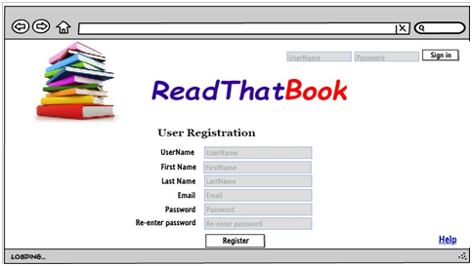

**Acceptance criteria:**

Given:

User is on User registration page

When:

User enters all the details which meet validation conditions and hits on

Username: abc

First name: abc

Lastname : abc

Email : abc@gmail.com

Password : avf12

Re-enter password : avf12

User clicks on - Register button

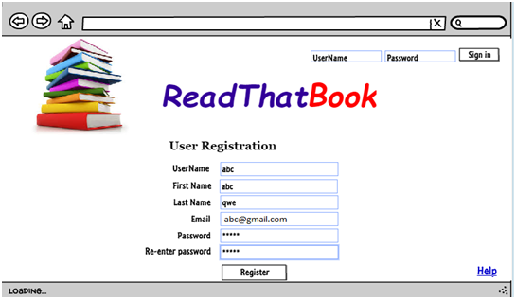

Then:

Application registers the users and displays homepage for the user

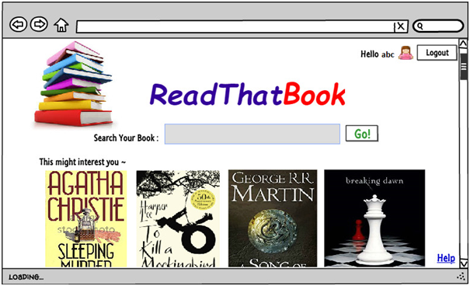

Acceptance criteria:

Given:

User is on User registration page

User entered valid inputs for first name, last name, username

When:

User enters password as ‘ikl123’ and re-enter password as ‘jkl321’ and clicks Register

Then:

Application shows error – passwords don’t match.

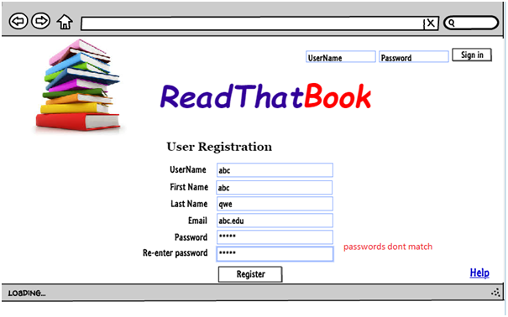

**Acceptance criteria:**

Given:

User is on User registration page

User entered valid inputs for first name, last name, password, re-enter password, username

When:

User enters email as abc.edu and clicks on Create account button.

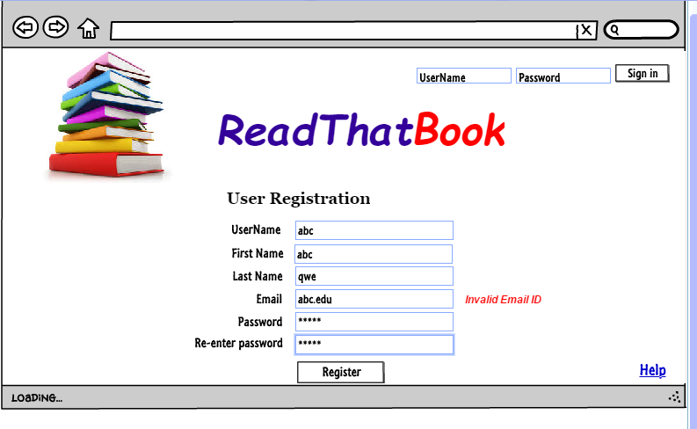

Then: Application shows error – invalid email id and browser retained on user registration page.

**Acceptance criteria:**

Given:

User is on User registration page.

A user abc is already registered with email id abc@gmail.com

When:

User enters email, field is abc@gmail.com and enters all other fields.

User clicks on Register button

Then:

Application shows error message “user with email id already exists”

Browser remains on User registration page

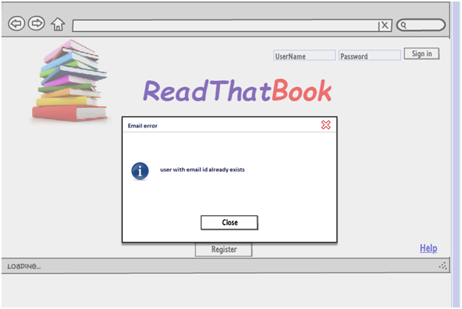

**Acceptance criteria:**

Given:

User is on User registration page

A username ‘qwerty’ is already exists in database

When:

User enters username ‘qwerty’

User enters valid entries for first name, last name, password, re-enter password and email fields

Then:

Application shows error message “User already exists with this user name..”

Browser remains on User registration page

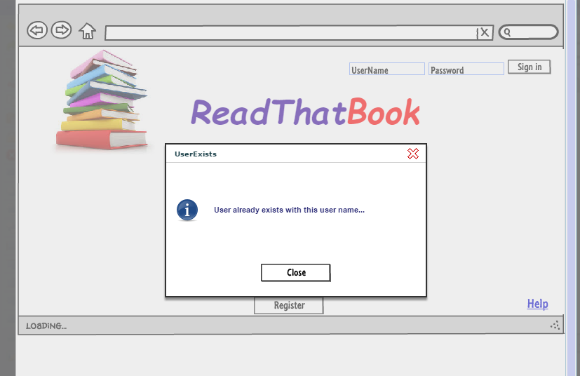

**Tasks:**

|  |
| --- |
| Code and Test UI for Register page |
| Code and test for Register user functionality using Authentication servlet |
| Code and Test UI for User registration page |
| Code and Test INSERT query on User table |
| Code acceptance test for "Register my account" functionality |
| Code and Test for Register action on Register user page |
| Code and test UserDB class for insert method |

**User Story :**

|  |
| --- |
| **As a user,I want to log into the system.** |

**Acceptance Criteria:**

Given:

User is at the “Log in” form of the application.

User XYZ already exists in database

When:

User enters the username XYZ and password. Entered details are valid.

User clicks on “Login” button.

Then:

Application redirects to the homepage of the user.

Username XYZ is displayed on the header of user home page.

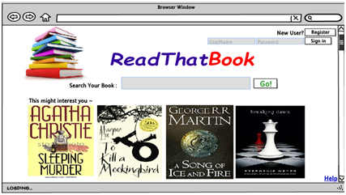

Acceptance Criteria:

Given:

User is at the “Log in” form of the application.

Username MNM doesn’t exist in database.

When:

User enters the username MNM and password. Entered details are invalid.

User clicks on “Login” button.

Then:

A message is displayed saying that “Invalid username or password!.”

User stays on the same login page.

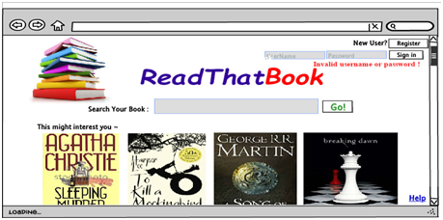

**Acceptance Criteria:**

Given: User is at the “Log in” form of the application.

When:

User does not enter the username but enters a password.

User clicks on “Login” button.

Then:

A message is displayed saying that “Username or password is missing.”

User stays on the same login page.

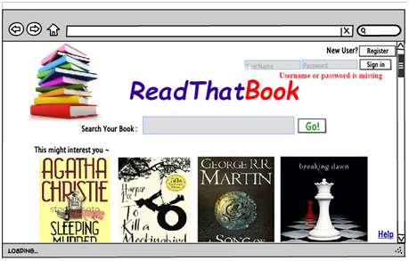

**Acceptance Criteria:**

Given:

User is at the “Log in” form of the application.

When:

User does not enter password but enters username.

User clicks on “Login” button.

Then:

A message is displayed saying that “Username or password is missing.”

User stays on the same login page.

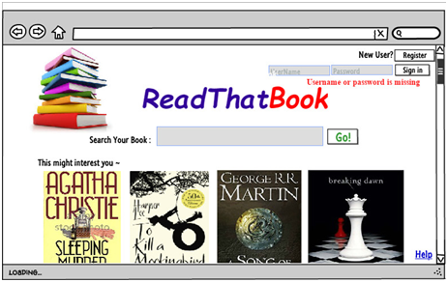

**Tasks:**

|  |
| --- |
| Create 'User' table in database. |
| Code and test UI for login functionality. |
| Code and test Authentication servlet for login action. |
| Code and test "IUser" interface and implement using concrete classes. |
| Create and test UI for user homepage. |
| Code and Test SELECT SQL query on USER table |
| Code and test for acceptance criteria of user login. |

**User Story :**

|  |
| --- |
| **As a user,I want to logout of the system.** |

**Acceptance Criteria:**

Given:

User is already logged in to his account in the application.

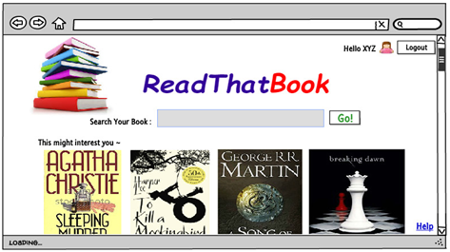

When:

User clicks on “Logout” button.

Then:

User returns to the homepage of the application.

The header does not display his username any longer.

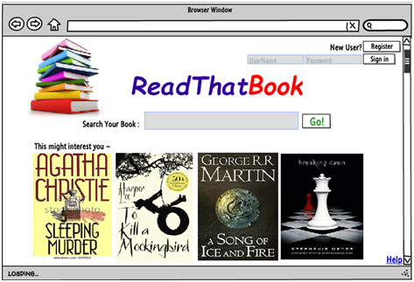

**Tasks:**

|  |
| --- |
| Code and test logout UI. |
| Code and test Authentication servlet for logout |
| Code acceptance tests for logout functionality |

**User Story :**

|  |
| --- |
| **As an admin, I want to delete books.** |

Acceptance Criteria:

Given:

User is already logged in as Admin.

He is on the “Manage Books” webpage.

Book ‘abc’ already exists in database.

When:

Admin clicks on delete button of book ‘abc’.

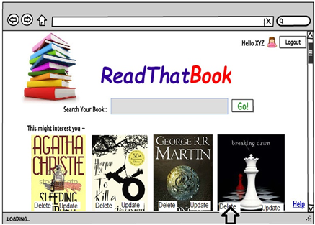

Then:

A pop up notification appears –“Are you sure you want to delete this book?”

User clicks on “Yes”.

“Book deleted successfully.”- Message is displayed.

Manage books page displays list of books in which book ‘abc’ is missing.

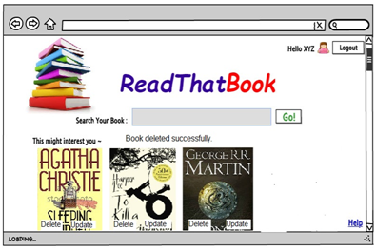

Acceptance Criteria:

Given:

User is already logged in as Admin.

He is on the “Manage Books” webpage.

Book ‘abc’ already exists in database.

When:

Admin clicks on delete button of book ‘abc’.

Then:

A pop up notification appears – “Are you sure you want to delete this book?” User clicks on “No”.

Manage books page displays list of books in which book ‘abc’ is present.

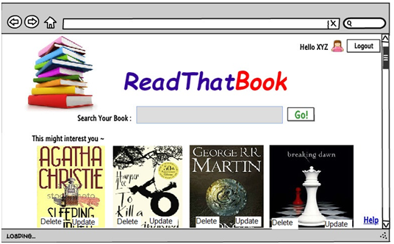

**Tasks:**

|  |
| --- |
| Code and test delete action on manageBooks page |
| Code and test for deleteBook method on BookUtility class |
| Code and test for DELETE SQL on Book table |
| Code and test for Acceptance criteria for book deletion user story. |
| Code and test BookManager servlet for delete book action |

**User Story :**

|  |
| --- |
| **As an admin, I want to update book details.**  **Acceptance Criteria**  Given: Admin is logged in to the system as “XYZ”  Admin is in Manage books  When: Selects book ‘ioga’ to update  Admin enters update book page  Admin updates title from “ioga” to “videos for life” , ISBN from 12345 to 09876  clicks on “Update Book”    Then:  Admin will be shown toast message saying "Book details updated"  Book titled “videos for life” in Manage books page ‘s list of books. |

**Acceptance criteria:**

Given: Admin is logged in to the system as “XYZ”

Admin is in Manage books

When:

Selects book to update

Admin enters Update book page

Admin changes Title from “ABC” to “” and ISBN to 09876

Then:

A message saying "Title should not be blank" will be displayed.

Book details of ABC are not updated.

Book with title ABC still displaying on Manage books page. And ISBN is 12345

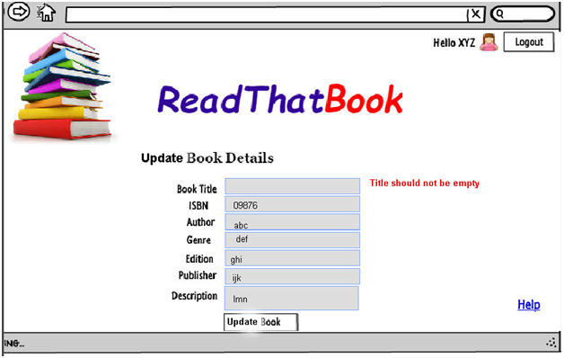

**Tasks:**

|  |
| --- |
| Code and test for update book button on manageBooks page |
| Code and test BookManager servlet for book update action |
| Code and test for BookDB class for updateBook method |
| Code and test UPDATE SQL on Book table |
| Code and test for acceptance criterion for update book action |

**User Story :**

|  |
| --- |
| As a guest user,I want to perform basic search for books using book title. |

**Acceptance criteria:**

Given:

User is on book search page.

Books with title ‘Harry Potter’ exist in the system

When:

User selects Title from drop down menu and enters ‘Harry Potter’ and hits Search.

Then:

Application displays books with title Harry Potter.

**Acceptance criteria:**

Given:

User is on book search page.

Mein Kampf book doesn’t exist in the database

When:

User selects Title from drop down menu and enters Mein Kampf and hits search

Then:

Application displays error message on book search page: Book Mein Kampf doesn’t exist on ReadThatBook.



**Tasks:**

|  |
| --- |
| Code and Test SELECT query on Book table |
| Code and Test UI for basic search field in User home page |
| Code and Test UI for basic search results page |
| Code and test for search functionality using BookManager servlet |
| code acceptance test for basic search functionality |
| Code and test for Search action on User home page |
| Code and test BookDB class for Search method |

**User Story :**

|  |
| --- |
| **As a user,I want to view list of books on my account homepage**  Acceptance criteria:  Given:  Assuming user is having access to application.  When:  user is on opens page url of the application .  Then:  Home page displays list of books on the home page |

**Tasks:**

|  |
| --- |
| Code and Test UI for home page of user account |
| Code acceptance criteria for home page of application |
| Code and test BookManager servlet for display books action |
| Code and test displayBooks method on BookUtility class |
| Code SELECT SQL on Books to retrive book details |

**User Story :**

|  |
| --- |
| As a guest user,I want to select a book and view its details. |

**Acceptance criteria:**Given: User is on books result page  
When: User clicks on link of book : Harry Potter and Goblet of Fire  
Then: Application displays books title , description , author , publisher , edition details.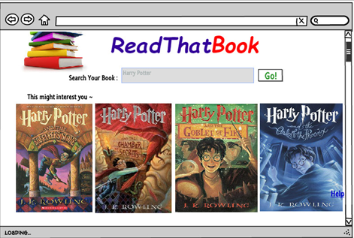

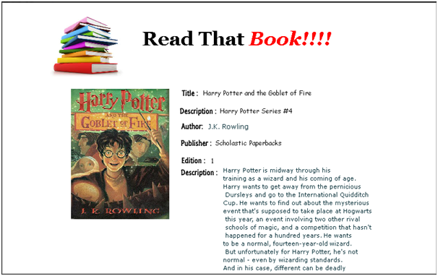

**Tasks:**

|  |
| --- |
| Code and Test SELECT query on Book table to retrieve details |
| Code and Test UI for bookDetails page |
| Code and test acceptance criteria for book details page |
| Code and test for BookList servlet for display book action. |
| Code and test display of all books on guestHome page and selection of particular book. |

**User Story :**

|  |
| --- |
| **As a user,I want to view my profile.** |

**Acceptance Criteria:**

**Given:**

User is logged in to his account

**When:**

User clicks on My AccountàView Profile tab from the header tool bar.

**Then:**

User account information page displayed with First Name, Last name, email id

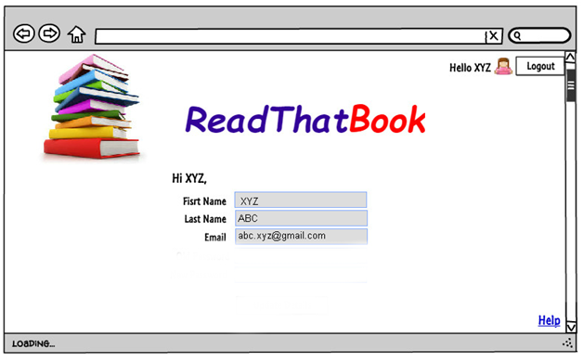

**Tasks:**

|  |
| --- |
| Code and test for viewProfile method of UserProfileManager class. |
| Code and test UI for myAccount page. |
| Code and test for view profile in UserProfileManager servlet |
| Code and test queries for viewing account details. |

**User Story :**

|  |
| --- |
| As a user,I want to delete my account. |

**Acceptance criteria:**

Given: User XYZ exists in database

User is logged in to his account

When:

User clicks on ‘My accountàDelete my account’ button

User should be asked for reconfirmation popup saying "Are you sure you want to delete your account?"

User clicks on ‘Yes’

Then: “User account XYZ is deleted” message is displayed

User session is ended.

Application redirects to home page with log in.

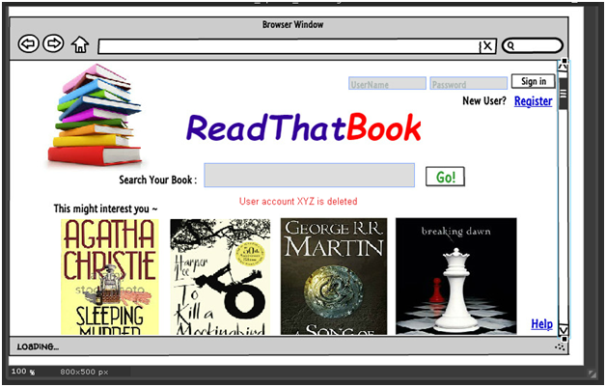

**Acceptance criteria:**

Given:

User XYZ exists in database

User is logged in to his account

When:

User clicks on ‘My AccountàDelete my account’ button

User should be asked for reconfirmation popup saying "Are you sure you want to delete your account?"

User clicks on ‘No’

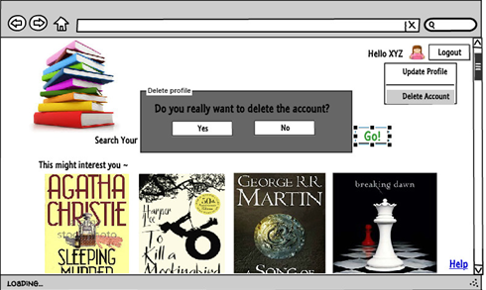

Then: User is not deleted

Application redirects to user home page.

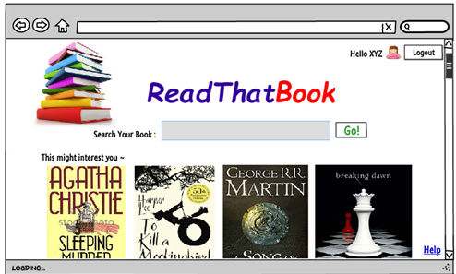

**Tasks:**

|  |
| --- |
| Code and test for delete action on MyAccount tab |
| Code and test for delete functionality in UserProfileManager servlet |
| Code and test for Acceptance criteria for user account deletion user story |
| Create table Archive_Users table |
| Code and test for DELETE SQL on Users table |
| Code and test INSERT query on Archive_Users table |

## **Sprint** **2**

**User stories, tasks and acceptance criterion:**

**User Story :**

|  |
| --- |
| **As a critic , I want to open critic account on system.** |

**Acceptance criteria:**

Given: User is on home page of the application

When: User clicks on Register button

Then: Application displays User registration form

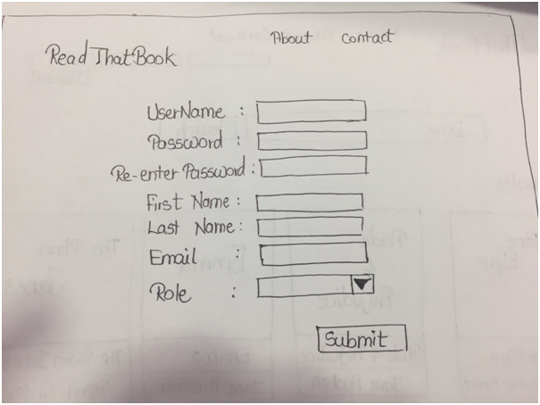

**Acceptance criteria:**

**Given:** User is on User registration page

**When:** User enters all the details which meet validation conditions

User Selects 'Critic' as User type

User clicks on Submit

Username: xyz

First name: xyz

Lastname : abc

Email : abc@gmail.com

Password : qwrty23!

Re-enter password : qwrty23!

User Type: Critic

User clicks on - Submit button

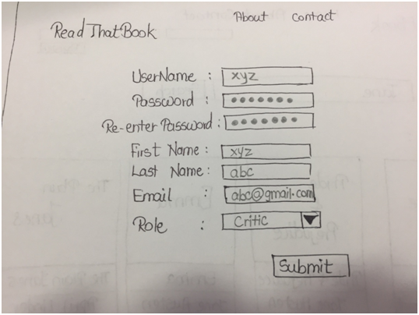

**Then:** Application registers the users and displays homepage for the user

**Acceptance criteria:**

Given: User is on User registration page

User entered valid inputs for first name, last name, password, re-enter password, username

When: User enters email as abc.edu and clicks on Submit button.

Then: Application shows error – invalid email id and browser retained on user registration page.

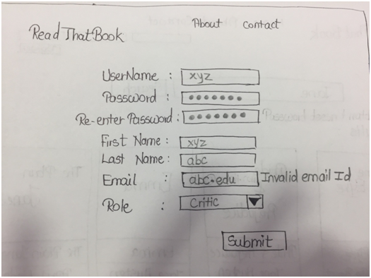

**Acceptance criteria:**

Given: User is on User registration page.

A user abc is already registered with email id xyz@gmail.com

When: User enters email, field is xyz@gmail.com and enters all other fields.

User clicks on Submit button

Then: Application shows error message “user with email id already exists”

Browser remains on User registration page

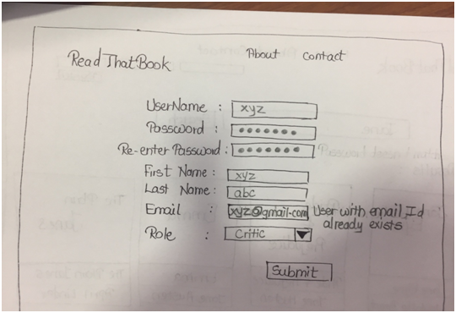

**Acceptance criteria:**

Given: User is on User registration page

A username ‘qwerty’ is already exists in database

When: User enters username ‘qwerty’

User enters valid entries for name, password, re-enter password and email fields

User clicks on Submit button

Then: Application shows error message “User already exists with this user name..”

Browser remains on User registration page

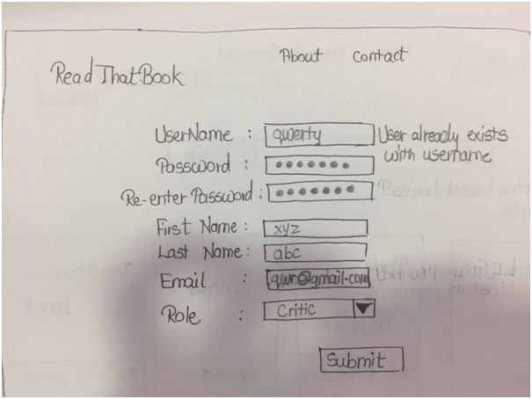

**Tasks:**

|  |
| --- |
| Code and test 'User Type' field in User Registration page. |
| Code Authentication servlet for add critic user addition |
| Code and test UserDB class for critic user addition |
| Code and test acceptance criteria for critic account creation user story |

**User Story :**

|  |
| --- |
| As a subscribed user , I want to create wishlist of books that I am planning to read. |

**Acceptance Criteria:**

Given:

User has successfully logged into the application.

When:

User clicks on Add to Wishlist button of a book.

Then:

Application stays on the same page.

Selected book gets added to wishlist.

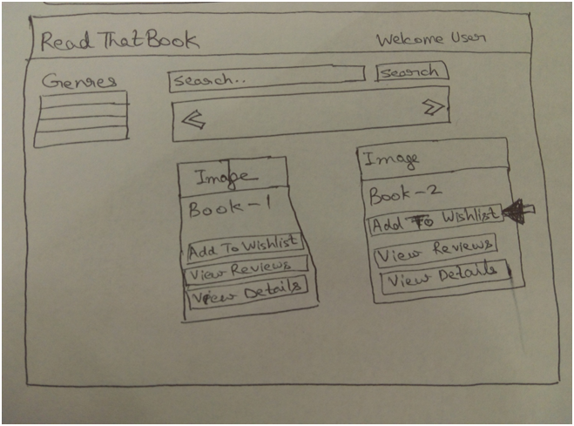

**Acceptance Criteria:**

Given:

User has successfully logged into the application.

When:

User clicks on Add to Wishlist button of a book.

Then:

Application stays on the same page.

Selected book does not get added to wishlist.

Following message is displayed : “This book has been already added to wishlist.”

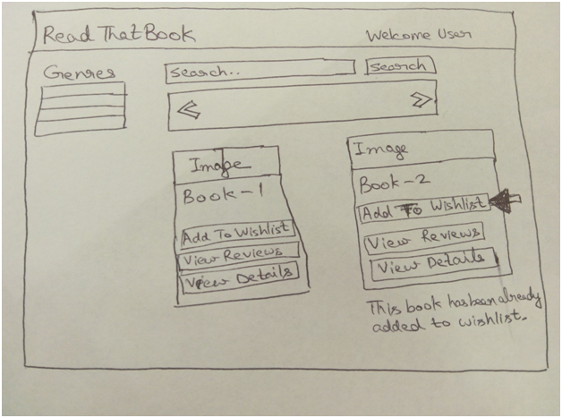

**Tasks:**

|  |
| --- |
| Code and test UI for creation of wishlist of books. |
| Create Wishlist table in database. |
| Code and test wishlistServlet. |
| Code and test SQL queries in WishlistDB to add books into wishlist table. |
| Code and test for acceptance criteria of wishlist creation. |
| Code and test Wishlist class. |

**User Story :**

|  |
| --- |
| As a user , I want to view book images along with the book title. |

**Acceptance Criteria:**

**Given:**User has access to ReadThatBook application via browser

Book Pride and Prejudice exists, Harry Potter exists in database are the books in db

**When:** User is on application home page

**Then:** All the books are displayed with images along with title.

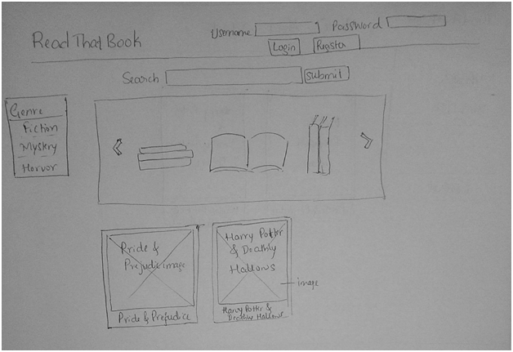

**Given:** User Sanju exists in the system

**When:** User Sanju logs into system.

**Then:** All books with details and image should be displayed on user home page

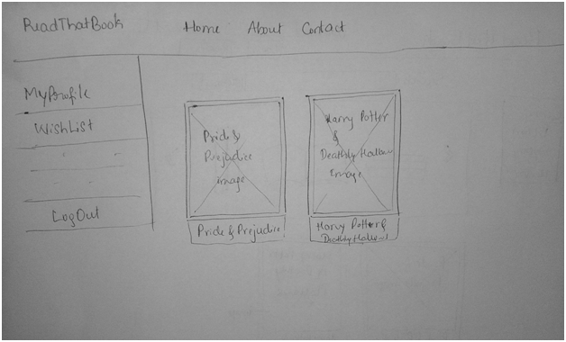

**Given:** User Sanju exists in the system

User logged into system

Book Pride and Prejudice exists

**When:** User clicks on book : Pride and Prejudice

**Then:** Book image should be displayed along with book details

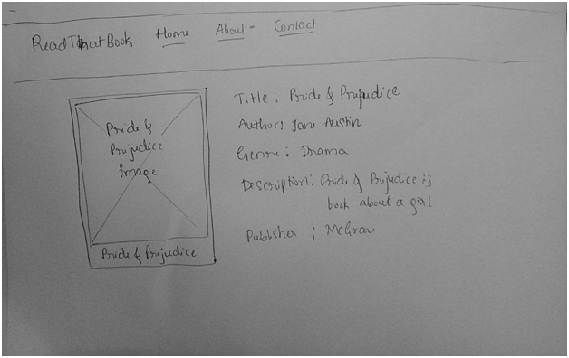

**Tasks:**

|  |
| --- |
| Code and test for adding image of book cover to the Book database |
| Code and test BookDB class for image insert into Database |
| Create BookImage table |
| Code and test UI for display of book covers |
| Code insert SQL into bookImage table |
| Code and test retrieval of book images from book image table |
| Code and test BookManager servlet for addition and retrieval of Book images |
| Code and test acceptance criteria for book image display |

**User Story :**

|  |
| --- |
| **As a user I want to search a book based on title or author name.**  **Acceptance criteria:**  Given:  User is on home page - book search textbox.  Books with title ‘Jane' and Author 'Jane' exist in the system  When:  User enters ‘Jane’ in search box and hits Search.  Then:  Application displays all books with title 'Jane' and author 'Jane'.    **Acceptance criteria:**  Given:  User is on home page - book search textbox.  **To Kill a Mocking** **Bird** book doesn’t exist in the database  When:  User enters 'To Kill a Mocking Bird' and hits search  Then:  Application displays message on result page: Book **To Kill a Mocking** **Bird** doesn’t exist on ReadThatBook. |

**Tasks:**

|  |
| --- |
| Code and test UI for search book toolbar with title or author name |
| Code and test for searchBook methods BookDB class for retrieval of book list with either title or author |
| Code and test BookManager servlet for view book lists request |
| Code and test for acceptance criteria for book search on title / author story |
| Display error message when book with given search string is not found in database |

**User Story :**

|  |
| --- |
| **As a subscribed user, I want to see ratings of a book.** |

**Acceptance Criteria:**

Given:

User is already logged in.

User can see list of books which are in DB.

When:

User clicks on “Harry Potter” book from book list

Then:

Book details will be displayed along with average ratings of the book

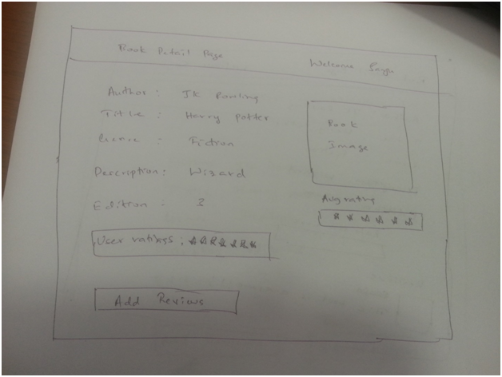

**Tasks:**

|  |
| --- |
| Add bookRatings table in the database |
| Code and Test UI for displaying book ratings to user |
| Code and Test BookManager servlet to retrieve ratings of a book |
| Code and test acceptance criteria for viewing ratings of a book |

**User Story :**

|  |
| --- |
| **As a subscribed user , I want to review books.** |

**Acceptance Criteria:**

Given:

User is already logged in.

He is on the “Book details” webpage and book details exist in BookDb.

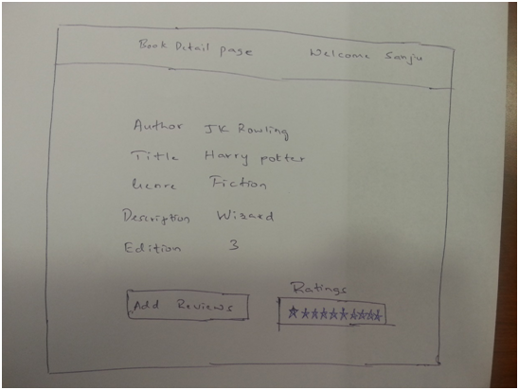

When:

User clicks on “Add Reviews” button

Then:

User should be prompted with edit field to enter the reviews

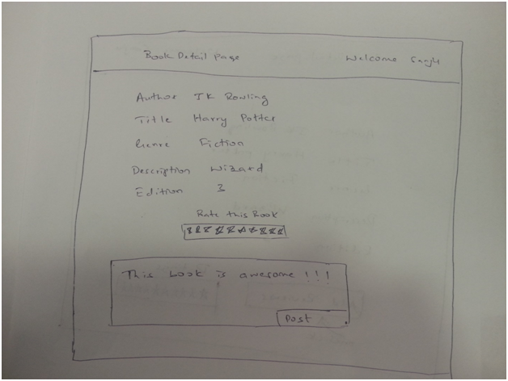

**Acceptance Criteria:**

Given:

User entered reviews in Review edit field.



When:

User clicks on “Post” button

Then:

Review should be shown below book details

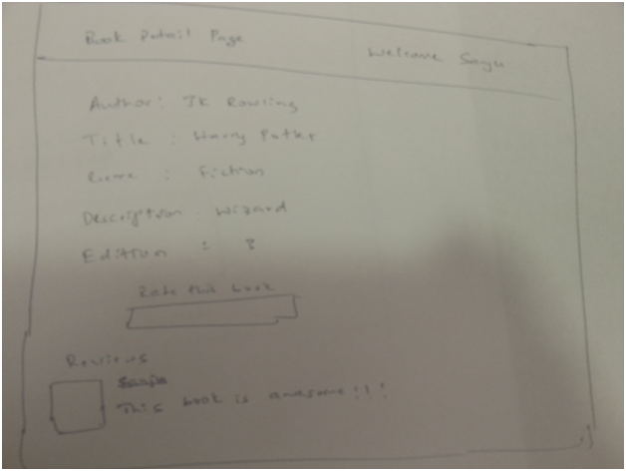

Acceptance Criteria:

Given:

User didn’t enter anything inside Review edit field.

When:

User clicks on “Post” button

Then:

User should be notified with error “Reviews cannot be empty

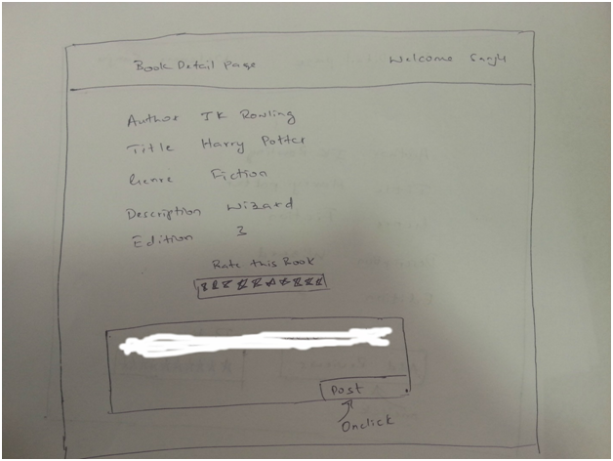

**Tasks:**

|  |
| --- |
| Code and test for creating Review class |
| Code and test for creating Review table |
| Code and test for Insert query on Review table |
| Code and test for Review book button on book details page |
| Code and test BookReviewManager servlet for Review book action |
| Code and test UI for reviewBooks webpage. |
| Code and test insertReview method in ReviewDB class |
| Code and test for acceptance criteria of review book details. |

**User Story :**

|  |
| --- |
| **As an admin , I want to add books directly from Google API.** |

Given:

User pmahend1 is an admin of the application

Admin has logged into the system

When:

Clicks on Manage books button.

Then:

User is redirected to ManageBooks page.

ManageBooks page should have a search bar for “Add books from Google Books”

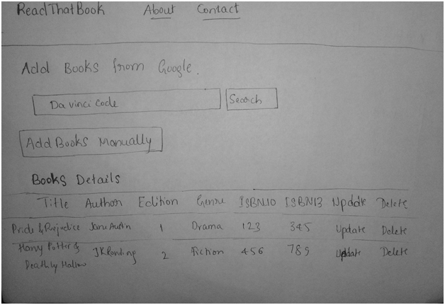

**Acceptance Criteria:**

Given: Admin user is on Mange Books page

Books named %Da vinci code% exist in Google books

When: User enters a query ’Da Vinci Code’ and hits enter for a book which already exists in Google books.

Then: The book results should be displayed on results from Google page for books containing title ‘Da vinci code’

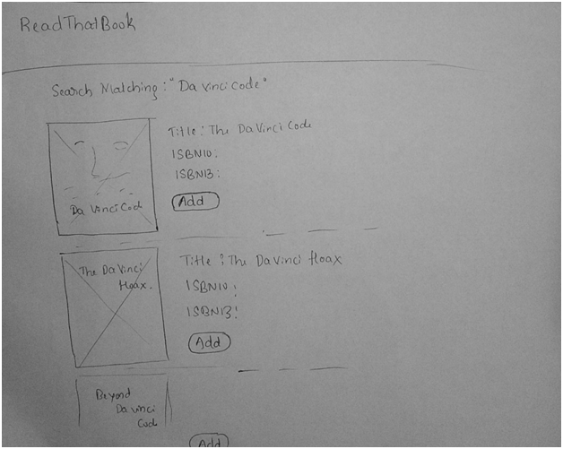

Given: Admin user is on Mange Books page

Learn gibberish book exists in Google books

When: User enters a query ’Learn gibberish’ and hits enter

Then: An error message should be displayed “Book learn gibberish doesn’t exist” in google books

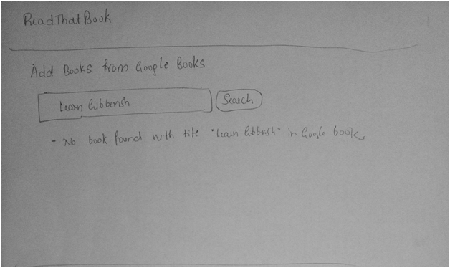

Given: Admin user is on Mange Books page

When: User enters a query with ISBN10 or ISBN13 field which is existing in google books

Then: Book with particular ISBN10 or ISBN13 should be displayed on results from google books page

Given: Admin user is on Mange Books page

When: User enters a query with ISBN10 or ISBN13 field which doesn’t exist in google books : 0000000000000

Then: An error message should be displayed on manage books page as “No books match with searched string “0000000000000”

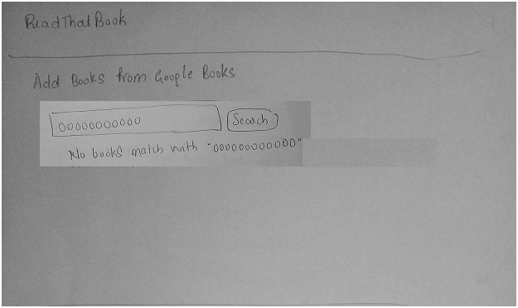

**Tasks:**

|  |
| --- |
| Code and test UI for add for google API search tool bar |
| Code and test GoogleApiServlet for usage of google books API |
| Code and test BookDB class to add books retrived by google API |
| Code for displaying added book details on admin manageBooks page |
| Code and test acceptance criteria for addition of books from google API |

**User Story :**

|  |
| --- |
| **As a subscribed user, I want to update my book wishlist** |

**Acceptance Criteria:**

Given:

User has successfully logged into the application.

User clicks on View Wishlist button.

Application redirects to wishlist page.

All books added to wishlist are displayed.

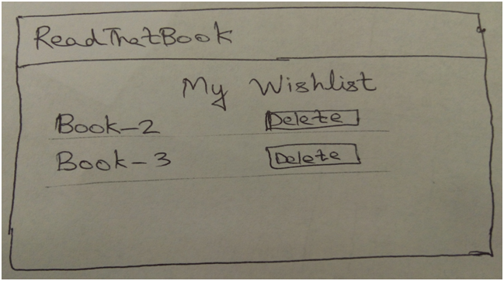

When: User clicks on Delete button.

Then: Deleted book is not displayed in the wishlist.

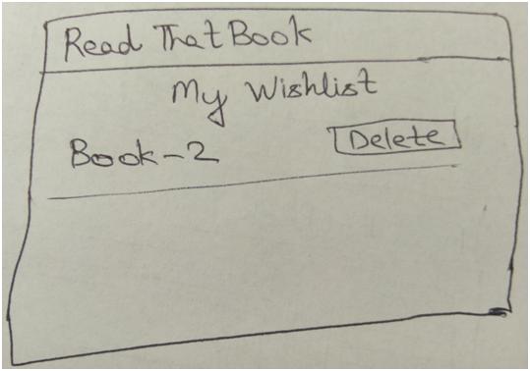

**Tasks:**

|  |
| --- |
| Code and test UI for update books wishlist |
| Code and test WishlistServlet for updation of wishlist |
| Code and test for WishListDB class for updation of wishlist items |
| Code and test for accptance criteria for wishlist update user story |

**User Story :**

|  |
| --- |
| **As a subscribed user , I want to rate a book.** |

**Acceptance Criteria:**

Given:

User is already logged in.

He is on the “Book details” webpage and book details exist in BookDb.

When:

User clicks on 7th Star in Ratings section

Then:

User ratings will be displayed

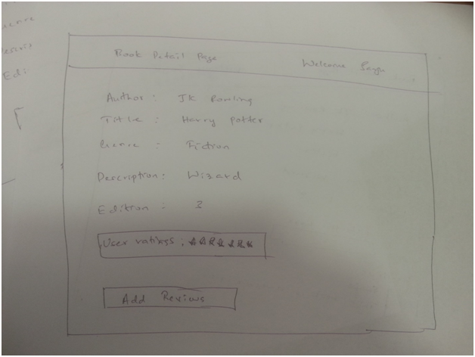

**Tasks:**

|  |
| --- |
| Code and test insertion of ratings for a particular book into database using SQL query |
| Code and test BookManager servlet for calculating and inserting rating of a book |
| Code and Test UI for rating a book |
| Code and test acceptance criteria for rating a book |

**User Story :**

|  |
| --- |
| **As a subscribed user, I want to read reviews of a book.** |

**Acceptance Criteria:**

Given:

User has successfully logged into the application.

When:

User clicks on View Reviews button of a book.

Then:

Application redirects to the reviews page.

Reviews for selected book can be viewed.

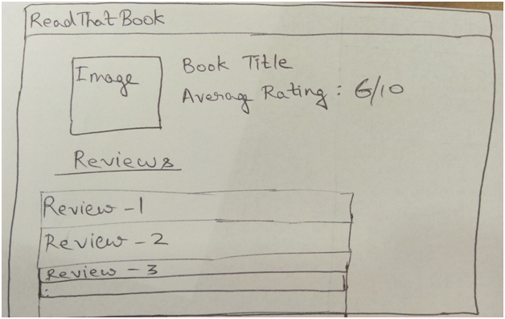

**Acceptance Criteria:**

Given:

User has successfully logged into the application.

When:

User clicks on View Reviews button of a book.

Then:

Application redirects to the reviews page.

Reviews for selected book don’t exist.

“No reviews exist for this book.” - Message is displayed.

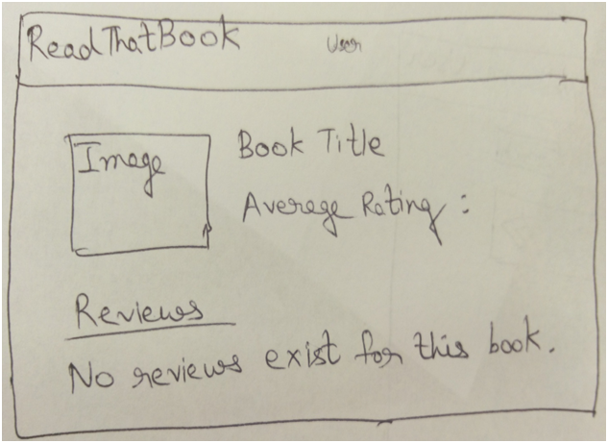

**Tasks:**

|  |
| --- |
| Code and test UI for display of reviews of a Book |
| Code and test ReviewServlet for display of Book reviews |
| Code and test ReviewDB class for view of reviews of book |
| Code and test acceptance criteria for reviews of a book |
| Code and test for Select query on Review table |

**Additional Tasks without user story -**

|  |
| --- |
| Create common header and footer for all web pages of application |
| Update application UI and make it responsive so that web page gets updated when window is resized |
| Code and test session validation for logged in user |

## **Sprint 3**

**User stories, tasks and acceptance criterion:**

**User Story :**

|  |
| --- |
| As an admin , I want to read Contact Us information from users  **Acceptance Criteria :** |

Given: User pmahend1 is an admin.

Admin is on Notifications page.

When: When admin clicks on notification of type Contact us.

Then: Contact Us query details should be displayed.

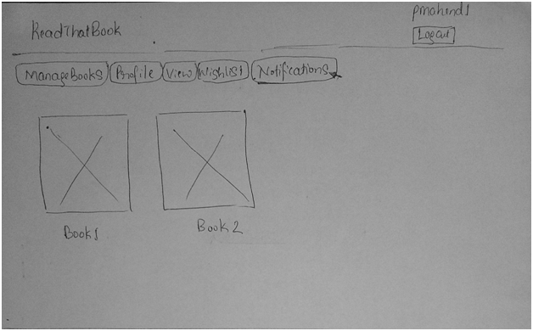

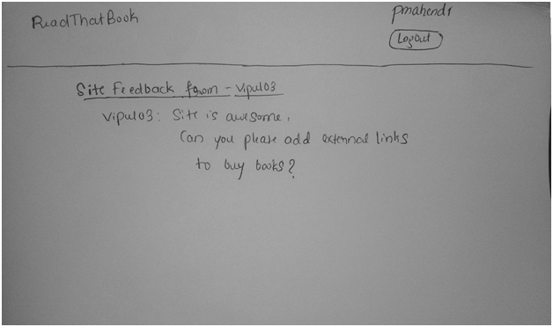

**Tasks:**

|  |
| --- |
| Code and test for UI pages for reading view contact us queries - viewContactUsQueries |
| Code and test servlet ContactUsServlet for reading feedback request |
| Code SQL for SELECT on ContactUs table |
| Code and test ContactUsDB for viewing feedbacks |
| Code and test acceptance criteria for reading reading Contact us queries functionality |

**User Story :**

|  |
| --- |
| As an admin, I want to verify the users with special provisions and approve their accounts. |

**Acceptance criteria:**

**Given:** User creates an account with user role as “Critic”.

Admin is in his home page

**When:** Admin clicks on notifications tab

**Then:** List of users asking for special provisions will be displayed

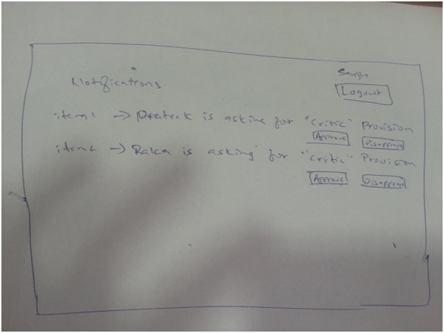

**Acceptance criteria:**

Given: Admin is in notification page.

When: Admin approves user requesting for special provision by clicking “Approve” below the message

Then: item will be removed from list of actions admin has to take. User is approved as “critic”

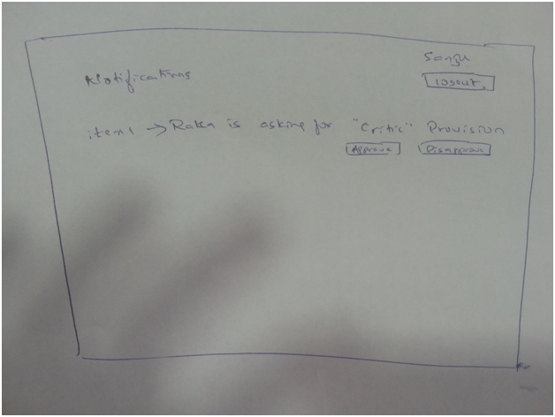

**Acceptance criteria:**

Given: Admin is in notification tab.

When: Admin disapproves user requesting for special provision

Then: item will be removed from list of actions admin has to take. User is not approved as “critic”



**Tasks:**

|  |
| --- |
| Code and Test Select query on User table for "critic" user role |
| Code and Test acceptance criteria for approving users with special provisions |
| Code and Test UI for approving users |
| Code and Test for showing list of users requesting for special provisions |
| Code and Test for retrieving list of users using AuthenticationServlet |

**User Story :**

|  |
| --- |
| **As a subscribed user, I want to read critic reviews and ratings.** |

**Acceptance Criteria:**

Given:

User has successfully logged into the application.

When:

User clicks on View Details button of a book.

Then:

Application redirects to the book details page.

Critic Reviews for selected book can be viewed at the top.

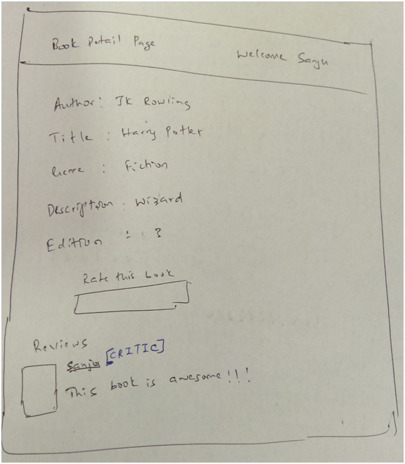

**Acceptance Criteria:**

Given: User has successfully logged into the application.

When: User clicks on View Reviews button of a book.

Then: Application redirects to the book details page.

Critic reviews for selected book doesn’t exist.

Reviews for selected book can be viewed.

But no reviews with “[CRITIC]” are visible.

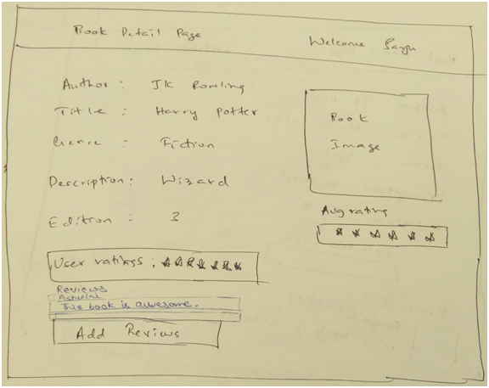

**Tasks:**

|  |
| --- |
| Code and test changes to UI for display of reviews and ratings of a Book. |
| Code and test changes to select queries on Review and rating table. |
| Code and test changes to ReviewDB and RatingDB class for view of ratings and reviews of book . |
| Code and test changes to ReviewManager and RatingManager servlet for critic Review and rating view action. |
| Code and test for acceptance criteria for viewing critic book review and rating. |

**User Story :**

|  |
| --- |
| **As a subscribed user , I want to see similar books that I searched for.** |

Acceptance Criteria:

Given: User has logged into his account and is on user home page.

When: User has searched for some book of his interest which is of genre 'Science Fiction'.

Then: Application displays book that user is searching for if it is present in database.

Application displays all books similar to search string depending upon the genre.

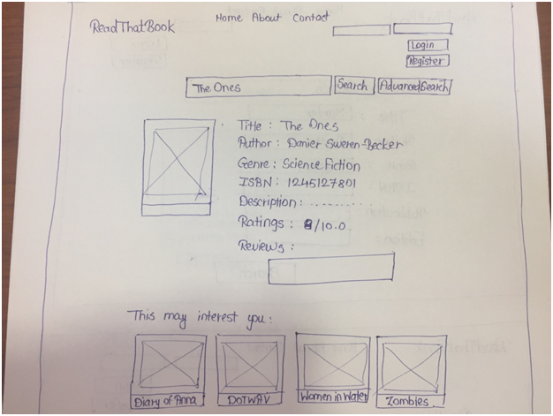

**Tasks:**

|  |
| --- |
| Code and test DisplaySimilarBooks in BookManager servlet to display books similar to searchString based on genre, title and author |
| Code and Test UI to display books similar tu user's search string on user page |
| Code and test acceptance criteria for displaying similar books one user home page |
| Code and test for DisplaySimilarBook methods BookDB class for retrieval of book list with same genre or author or title  **User Story :** |
| **As an admin , I want to delete reviews which are reported as spam or abusive.**  Acceptance Criterion:  Given: Review on a book already exists.  User/s has/have already reported a review as abusive or spam.  Admin pmhend1 has logged in.  When: Admin clicks on Notifications link  Then: Notifications display on page.      Given: Admin is on Notifications page  When: When admin clicks on the notification which is reported as abusive  Then: Notification detail will be shown with link to page which has abusive review    Given: Admin is on Notification detail page of abusive review.  When: When admin clicks on the link for abusive review  Then: Browser redirects to book detail page with reviews with Delete Review button for abused review.    **Given:** Admin is on book details page.  **When:** When admin clicks on the delete review button.  **Then:** Review should be deleted.    Given: Admin is on book details page.  When: When admin clicks on the home page link  Then: Admin should be redirected to home page.    **Tasks:** |
| Code and test UI changes for delete or keep reviews functionality |
| Code for ContactUsServlet for the action to be taken for a review reported as spam. |
| SQL code and test for delete review from REVIEW table |
| Code ReviewDB class to delete review |
| Code and test for acceptance criteria |

**User Story :**

|  |
| --- |
| **As a subscribed user , I want to have 'Contact Us' feature so that I can submit queries/feedbacks to admins** |

**Acceptance Criteria:**

Given:User raka already exists. Contact Us link exists in all the pages of the application.

When: User clicks on Contact Us link from footer of the page.

Then: A form opens up with dropdown for category of the query and text area.

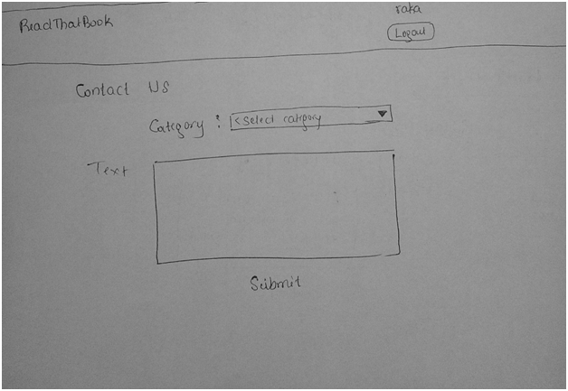

**Given:** User raka already exists.

User is on Contact Us page

**When:** User selects a category (as feedback) and submits feedback with text of 100 characters.

**Then:** User query should be submitted

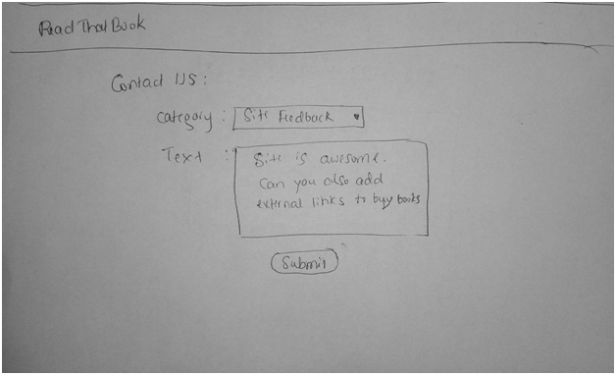

**Given:** User raka already exists.

User is on Contact Us page

**When:** User selects a category (as feedback) and submits feedbackwith empty string.

**Then:** An error should be displayed “Text should be minimum of 50 characters.”

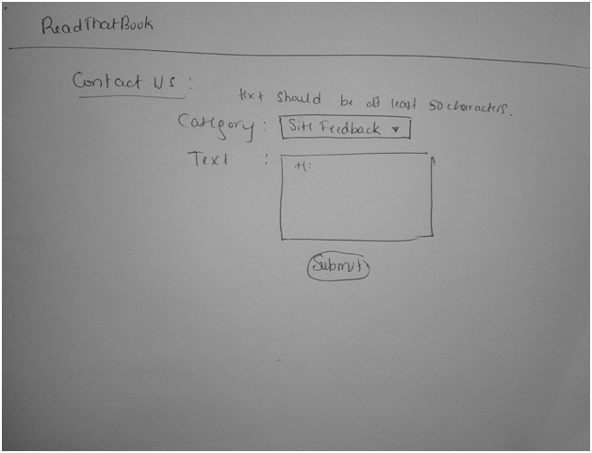

**Tasks:**

|  |
| --- |
| Code and Test UI for Contact Us page |
| Code and test ContactAdmin servlet |
| Code and Test ContactAdmin table in database which stores feedback/comments given by user |
| Code and test acceptance criteria for handling Contact us information for site improvement |
| Code and test ContactAdminDB class for handling contact us queries into ContactUs table |

**User Story :**

|  |
| --- |
| **As a subscribed user , I want to report abuse an offensive review.** |

**Acceptance criteria:**

Given: User is in view book details page of the application.

Some reviews from other users will exist for the book.

User finds one of the review as offensive

When: User clicks on “Report spam” button

Then: User should be asked with confirmation popup saying “Are you sure you want to report this review as spam?“

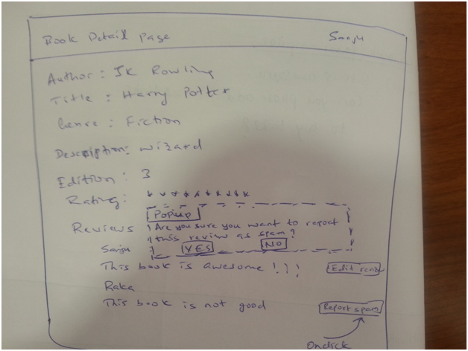

**Acceptance criteria:**

Given**:** User is in view book details page of the application.

Some reviews from other users will exist for the book.

User finds one of the review as offensive and clicks on “Report abuse” button.

User is asked with confirmation popup saying “Are you sure you want to report this review as spam ?“

**When:** User clicks on “Yes” button

**Then:** “Report spam” button is disabled



**Acceptance criteria:**

Given**:** User is in view book details page of the application.

Some reviews from other users will exist for the book.

User finds one of the review as offensive and clicks on “Report abuse” button.

User is asked with confirmation popup saying “Are you sure you want to report this review as abuse?“

**When:** User clicks on “No” button

**Then:** “Report spam” button should not be disabled

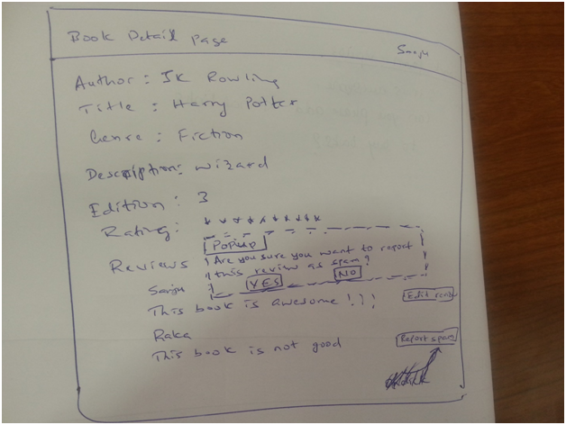

**Tasks:**

|  |
| --- |
| Code and Test for creating table "spam" |
| Create a class "spam" for storing details of review |
| Code and Test for acceptance criteria of spam reviews |
| Code and Test for Insert query on "spam" table |
| Code and Test for SpamServlet to create and retrieve offensive reviews |
| code and Test for insert query on notification- contact_us table. |
| Code and Test for "Report spam" button on Reviews |

**User Story :**

|  |
| --- |
| **As a critic , I want to rate and review a book.** |

**Acceptance Criteria:**

Given:

User is already logged in.

He is on the “Book details” webpage and book details exist in BookDb.

When:

Critic selects the rating and clicks on “Rate”

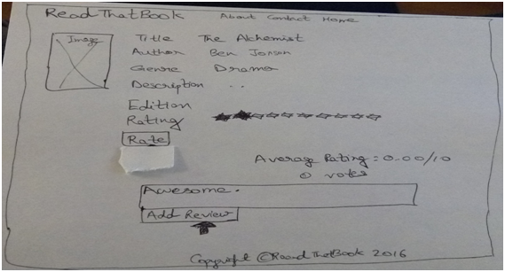

Then:

Critic rating will be displayed.

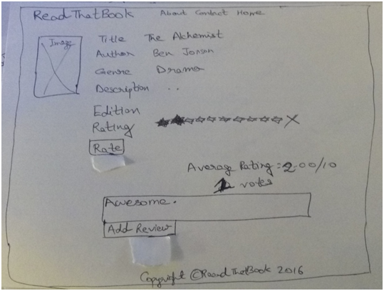

**Tasks:**

|  |
| --- |
| Make changes in Code for creating Review and rating and test them. |
| Code and test changes to insert queries on Review and rating table. |
| Code and test changes to UI for reviews and ratings. |
| Code and test for acceptance criteria of critic book review and rating. |
| Code and test changes to ReviewManager and RatingManager servlet for critic Review and rating action. |
| Code and test changes to methods in ReviewDB and RatingDB class . |

**User Story :**

|  |
| --- |
| As a user,I want to perform advanced search for a book using any combination of title,author,ISBN,genre of a book. |

Given**:** User has logged into his account

User is on advanced search textbox.

Books with title ‘Jane' and Author 'Jane' exist in the system

When:

User enters ‘Jane’ in search box and hits Search.

Then:

Application displays all books with title 'Jane' and author 'Jane'.

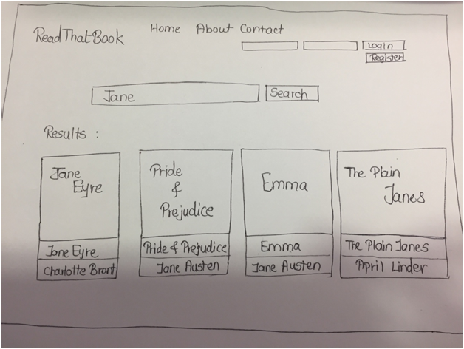

Given**:** User has logged into his account

User is on advanced search textbox.

Books with ISBN 8264537205 exist in the system

When:

User enters 8264537205 in search box and hits Search.

Then:

Application displays book with exact ISBN number 8264537205 present in database.

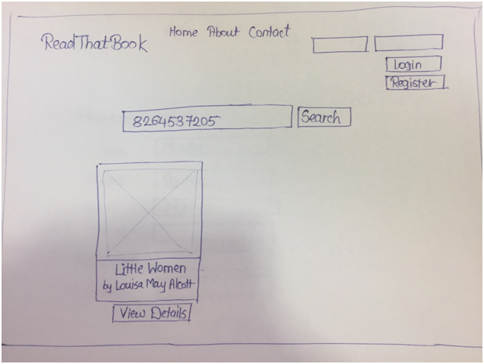

Given:User has logged into his account

User is on advanced search textbox.

Books with ‘Mystery' as genre, 'Agatha' as Author and 'Murder' as Title exist in the system

When:User enters ‘Mystery' as genre, 'Agatha' as Author and 'Murder' as Title in advanced search box and hits Search.

Then: Application displays all books with genre 'Mystery' and 'Agatha' as Author and 'Murder' as Title that are present in database.

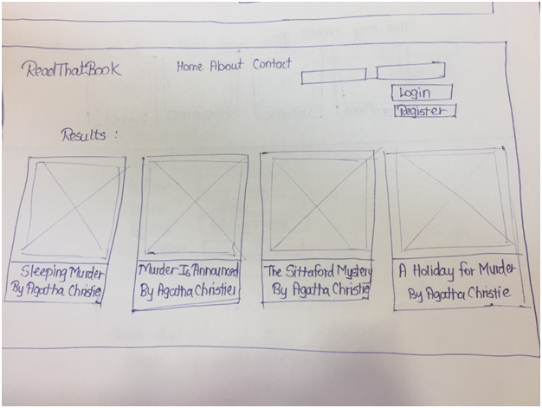

**Given:** User has logged into his account

User is on advanced search textbox.

Books with ISBN 8264537205 and genre 'Comedy' does not exist in the system

**When:** User enters ISBN 8264537205 and 'Comedy' as genre in advanced search box and hits Search.

**Then:** Application displays message : Book does not exist in our database

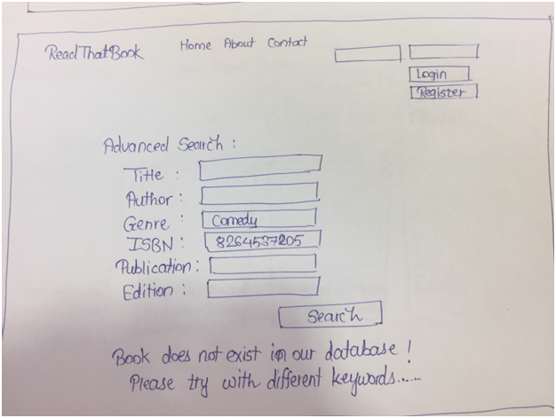

**Tasks:**

|  |
| --- |
| Code and test UI changes for advanced search Search bar and additional options |
| Code and test BookManager servlet for handling advanced search request |
| Code and tes DB class for advanced search functionality |
| Code using JPA(Java Persistent API) to perform advanced search  Code and test acceptance criteria for advanced search |

# **Testing**:

We have used JUnit for unit testing.

For the UI,we did manual testing.We manually tested each functionality using multiple relevant input.

## **Test 1:**

**Requirement(s) under test:**

As a subscribed user , I want to rate a book.

**Function(s)/Module(s) under test:**

updateRating funtion : updateRating(rating);

**Initial conditions:**

Mock database contains user=”sanjukh” and bookid=2

**Assumptions:**

Rating for bookid=2 and user="sanjukh" exists in database.

**Test case input:**

Rating(2, "sanjukh", 6); Here,value of updated rating=6.

**Expected result:**

After the update function is called,the rating value for bookid=2 and user="sanjukh" is read.The rating value should be 6 now.

RatingDB.getUserRating(2, "sanjukh")=6

**Test case Passed.**

**Result:** <Passed>

## **Test 2:**

**Requirement(s) under test:**

As a subscribed user,I want to create wishlist of books that I am planning to read.

Code and test Wishlist class.

**Function(s)/Module(s) under test:**

getBookID() function

**Initial conditions:**

Mock database contains user=”sanjukh” and bookid=100.

**Assumptions:**

Wishlist for user=sanjukh contains only one book and its bookid=100.

I.e, wishlist.setBookID(100); is already executed.

**Test case input:**

Call the getBookID() function on created wishlist object.

**Expected result:**

The getBookID function returns 100.Test case Passed.

**Result**: <Passed>

## **Test 3:**

**Requirement(s) under test:**

As a user,I want to view list of books on my account homepage

**Function(s)/Module(s) under test:**

selectAllBooks() function

**Initial conditions:**

Books have been already added to the mock.Hence,number of books>0.

**Assumptions:**

Initially,an integer variable sum is set to 0.Hence, sum=0.

**Test case input:**

selectAllBooks functions is invoked on the object for database containing list of books i.e, BookDB.selectAllBooks(); is executed.

**Expected result:**

We pass through the entired result set using a loop.At each iteration, current bookID is added to previous value of the variable s.Finally,the value of the variable sum is the sum of the bookId of all the books in the resultset. So,the condition sum>0 is true.Test case Passed.

**Result**: <Passed>